Date: 15.08.2025 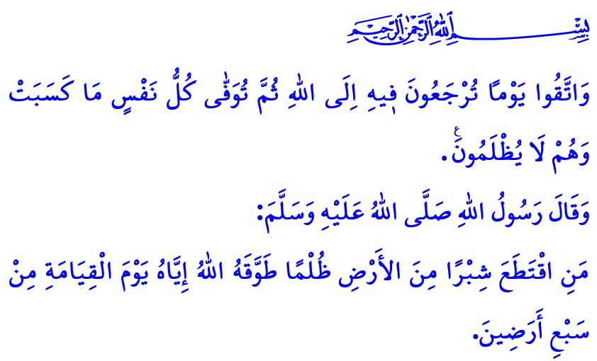
VIOLATING THE RIGHTS OF OTHERS EQUALS WEARING A GARMENT OF FIRE
Honorable Muslims!
One day, our Prophet (saw) asked his Companions, “Do you know who the bankrupt is?” The Companions replied, “It is the one who has lost his wealth and possessions, having gone bankrupt.” The Messenger of Allah (saw) then said: “The bankrupt from my nation is the one who will come on the Day of Judgment with prayers, fasting, and zakat. Yet he will have insulted this person, slandered that person, unlawfully consumed the wealth of another, shed someone’s blood, and beaten yet another. So his good deeds will be taken and given to those whom he wronged. If his good deeds run out before justice is fulfilled, their sins will be taken and cast upon him, then he will be thrown into the Hellfire. That is the true bankrupt.”
Dear Believers!
At the root of all evils experienced within the family, in society, and across the world lies the violation of people’s rights. Sadly, people’s rights are at times violated out of habit, at times through neglect and heedlessness, and at times with deliberate intent. The preservation of life, religion, property, intellect, and lineage is among the most fundamental principles of Islam. These rights are sacred and inviolable in the sight of Allah. Their violation is a grave burden of responsibility, a great injustice, and an infringement upon the rights of others.
Esteemed Muslims!
The gravest violation of people’s rights is to take an innocent life. Tragically, today, Zionist oppressors continue to commit this crime against humanity before the eyes of the world. Our Lord’s warning on this matter is unequivocal: “And whoever kills a believer intentionally, their reward will be Hell—where they will stay indefinitely. Allah will be displeased with them, condemn them, and will prepare for them a tremendous punishment.” Our duty, then, is not to remain silent in the face of oppression around the world, particularly in Gaza, and to strengthen our material and spiritual support for the oppressed.
Dear Believers!
Altering the inheritance shares ordained by our Almighty Lord without mutual consent contravenes divine justice. Accordingly, a person’s depriving his daughters of their inheritance, as well as the daughters’ refusal to accept their rightful share ordained by Allah, constitutes a violation of people’s rights. Violating land boundaries and seizing another’s property, confiscating people’s possessions on unfounded pretexts, and wronging people through false statements is to wear a garment of fire. In the hadith I recited at the beginning of the khutbah, the Messenger of Allah (saw) says: “Avoid taking the land unjustly. Whoever usurps the land of somebody unjustly, his neck will be encircled with it down the seven earths on the Day of Resurrection.”
Dear Muslims!
Showing favoritism or failing to act justly among employees constitutes a violation of people’s rights. An employer’s failure to pay wages fully and on time, assigning work beyond an employee’s capacity, or employing them without providing insurance constitutes a violation of people’s rights and is a sin. Similarly, an employee who damages the employer’s property, disregards working hours, or obtains a sick leave without being ill also violates people’s rights and commits a sin.
Constructing a building without conducting a proper ground survey, using insufficient or substandard construction materials is deceitful towards others and constitutes a violation of people’s rights. Moreover, applying different prices to foreigners visiting our country or to our brothers and sisters coming from abroad, and deceiving them in trade by taking advantage of their lack of knowledge constitutes a violation of people’s rights and is sin.
Dear Believers!
In any sector, purchasing a producer’s goods below their value and selling them at inflated prices, adding harmful substances to extend a product’s shelf life, or putting expired products on the market constitutes a violation of people’s rights and is sin. Hoarding and profiteering to raise prices, cheating in measurements and scales, or concealing defects in a faulty product when selling it constitutes a violation of people’s rights and is haram. Indeed, our Prophet (saw) emphasizes the gravity of this matter by saying: مَنْ غَشَّنَا فَلَيْسَ مِنَّا “Whoever deceives us is not one of us.” Additionally, occupying streets and sidewalks that are meant for public use for personal gain, thereby obstructing people from walking, constitutes a violation of people’s rights. Spreading false or misleading information on social media and digital platforms to slander others and harm their honor also constitutes a violation of people’s rights and is sin. What befits a Muslim is to be content with what is halal and never resort to what is haram. It entails refraining from speaking against anyone’s honor and dignity, and not coveting another person’s property.
Dear Muslims!
The awareness of people’s rights begins within the family. It takes root through proper education and spiritual awareness. Let us remember that the violation of the rights of others is among the gravest of reckonings on the Day of Judgment. Without seeking the rightful owner’s pardon and without compensating for their material and spiritual losses, there can be no escape from the severe punishment of the Hereafter.

I would like to conclude this Friday’s khutbah with the meaning of verse 281 of Surah al-Baqarah: “Be mindful of the Day when you will ˹all˺ be returned to Allah, then every soul will be paid in full for what it has done, and none will be wronged.”

Muslim, Birr, 59.
Nisa, 4/93.
Muslim, Musaqah, 137.
Muslim, Iman, 164.
Baqarah, 2/281. General Directorate of Religious Services

